A Continuous Event Simulation Model of
Intersection Road Traffic

Andriey Ronwyll Nacion
Computer Science Department
BSCS NS – 3C
Technological University of the Philippines
Manila, Philippines
andrieyronwyll.nacion@tup.edu.ph
Angelica Poblete
Computer Science Department
BSCS NS – 3D
Technological University of the Philippines
Manila, Philippines
angelica.poblete @tup.edu.ph
Al-Joshua Tende
Computer Science Department
BSCS NS – 3D
Technological University of the Philippines
Manila, Philippines
aljoshua.tende@tup.edu.ph
Cesar Angelo Bayudan
Computer Science Department
BSCS NS – 3D
Technological University of the Philippines
Manila, Philippines
cesarangelo.bayudan @tup.edu.ph

Abstract — The quick expansion of computer technologies, the evolution of software engineering and the advent of the intelligent transport systems has prompted traffic simulation to become one of the most used approaches for traffic analysis in support of the design and evaluation of traffic systems. The ability of traffic simulation to emulate the time variability of traffic phenomena makes it a unique tool for capturing the complexity of traffic systems. In this study, Researchers used Anylogic Simulation to create a Continuous-Event simulation model of Intersection road with traffic lights that will simulate the flow of traffic and the vehicles on the simulation model. This Traffic simulation based on the emulation of traffic flows from the dynamics of individual vehicles is becoming one the most attractive and accurate approaches.
Keywords— Continuous-event, simulation and modeling, anylogic Simulation Software, traffic analysis, time variability.

Introduction
Traffic modelling is aimed to accurately recreate traffic as observed and measured on street. Traffic modelling assumed the appearance of a traffic system without replicating. It was developed based on modeller’s experience that integrate the mathematical models into traffic system [1]. Traffic modelling plays an important part in traffic engineering. It can be applied to plan and manage the traffic within certain road network [2]. For example, making a smooth traffic at an intersection and etc [3].
Principally, simulation models focus on three output values to solve traffic problems [4]. First is the traffic flows. In traffic flows, alternative routes can be identified based on the number of vehicles. By using the simulation model, modeller can devise on how to reduce the levels of congestion of certain roads. Second output is the network element. Network element in traffic simulation consists of link, merge, link cross and other elements of the road [5]. This is related to the geometric layout of the road. Using appropriate simulation software, the road geometric design can be changed to see how it can influence the current traffic situation. Third output is the skim category. Simulations model can help to estimate the time and cost of travel. This is especially used when the assessment of traffic improvement is needed to be measured. The transport planner can easily make a performance comparison without any extra cost of money and time.
I. 1. AnyLogic
Each modelling approach has its advantages and disadvantages. Therefore, the so-called hybrid or multimethod modelling tools are being developed that allow integrating multiple modelling approaches and making the most of each. This makes it possible to achieve higher modelling and simulation efficiency. One such tool is AnyLogic (www.anylogic.com) –the general-purpose simulation tool for creating dynamic environments [6]. It integrates three basic modelling principles, each of them recommended under different conditions:
- System dynamics modelling (if there is only information about global dependencies);
- Discrete event modelling (if a system is easily described as a process);
- Agent-based modelling (if there are many independent objects).
System dynamics approaches system modelling at a high level of abstraction, i.e. it ignores small details and creates a general representation of a complex system. The basic concepts of this approach are feedback loops. Mathematically, the model of non-linear dependencies in the real-world maps to a system of differential equations that are solved numerically. AnyLogic offers the object-oriented approach and enables complex models to be defined in a hierarchical manner with objects only exposing interface variables as inputs and outputs.
Discrete event modelling models processes at a medium level of abstraction when physical details are not represented. It is appropriate when the system under analysis can be described as a sequence of operations. Classic discrete event tools work with passive entities having certain attributes only. Agent based modelling focuses on the individual active components of a system. Agents may have their individual behavior and state changes and connections between them may be established.
Agent-based models are usable at all levels. The global dynamics of the system then emerge from the interactions of the many individual behaviors.

Methods

Macroscopic Modelling
Macroscopic modelling describes the intersections at a low level of detail [7]. In macroscopic model, traffic stream is represented in an aggregate measured in terms of characteristics like speed, flow and density. Flow, speed and density are the three main characteristics of traffic. The researchers have studied speed-flow-density relationships and have attempted to develop mathematical descriptions for these curves, which is Greenshields’s Model and Greenberg Model. Greenshields’s Model is used to develop a model of uninterrupted traffic flow [8] it is a fairly accurate and simple modelling. There are three characteristics of the graph.
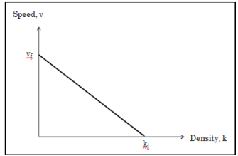
Figure 1. Speed, v versus Density, k

Greenshied’s Model shows the relationship between
speed and density is linear. When density increases, flow
decreases to an optimum when more vehicles were on
the road. The speed also decreases due to the interaction
of vehicles.
Greenshields’s Model shows the relationship between speed and density is linear. When density increases, flow decreases to an optimum when more vehicles were on the road. The speed also decreases due to the interaction of vehicles.
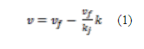
Where,
v = speed (km/h)
k = density (veh/km)
vf = free mean speed (veh/km)
kj = jam density (veh/km)

Eq. 1. Speed, v
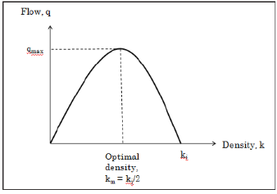
Figure 2. Flow, q versus Density, k
Greenshield’s model shows that the relationship between
flow and density is a parabolic curve.
Greenshields’s model shows that the relationship between flow and density is a parabolic curve.
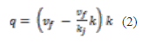
Where,

q = flow
Where,
q = flow
Eq. 2. Flow, q

When flow is very low, speed is higher. The drivers are
able to travel at a desired speed. As the flow increases,
speed gradually decreases. The highest flow shows the
transition of non-congested to congested condition.
When flow is very low, speed is higher. The drivers are able to travel at a desired speed. As the flow increases, speed gradually decreases. The highest flow shows the transition of non-congested to congested condition.
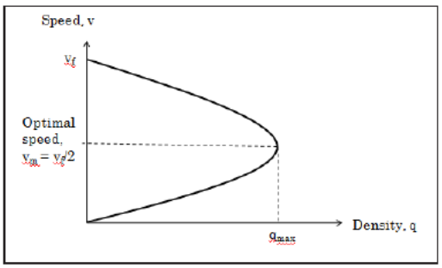
Fig. 6. Speed, v versus Density, k
Figure 3. Speed, v versus Density, k
Greenshield’s model shows the relationship between speed and
density.
Greenshields’s model shows the relationship between speed and density.
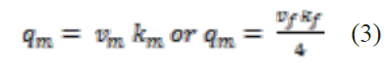
Where,
qmax = maximum flow
vmax = optimal speed
kmax = optimal density

Eq. 3. Maximum Flow

When the capacity (qmax) is in the maximum flow, the density is increasing and the speed will decrease due to the maximum number of vehicles passing to a certain point. The characteristics of congested unstable flow is high density and low speed. There is no gap for vehicles to enter. The characteristics of uncongested stable flow is slow density and high speed, when there are gaps for merging lane.

Simulation Model Flowchart
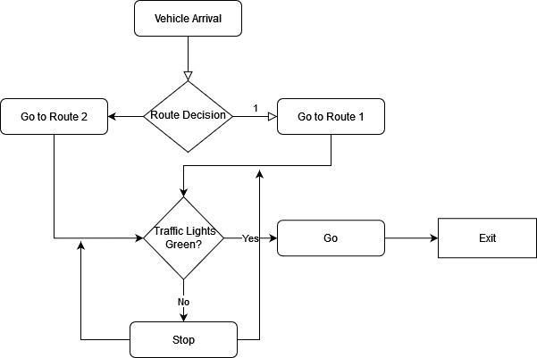

Figure 4. Simulation Model Flowchart

The flowchart of the model shows the flow of the simulation. Simulation starts on the Car Arrival which will spawn vehicles in their designated target road then after it will come to decision which will decide where the vehicle will go. The decision has a balance probability for each possible outcome depends on the used connector. After the Vehicle Agent decides he will go now on their decision output. Before passing the intersection and taking their targeted road, Traffic System will control the volume of the cars to avoid crash. Traffic System will stop the red light lane and the green light will pass. After passing the intersection, the cars will now go to their targeted road and exit on the end of backward lane. Every road has the same process of flowchart.

Simulation Model using AnyLogic Simulation Software
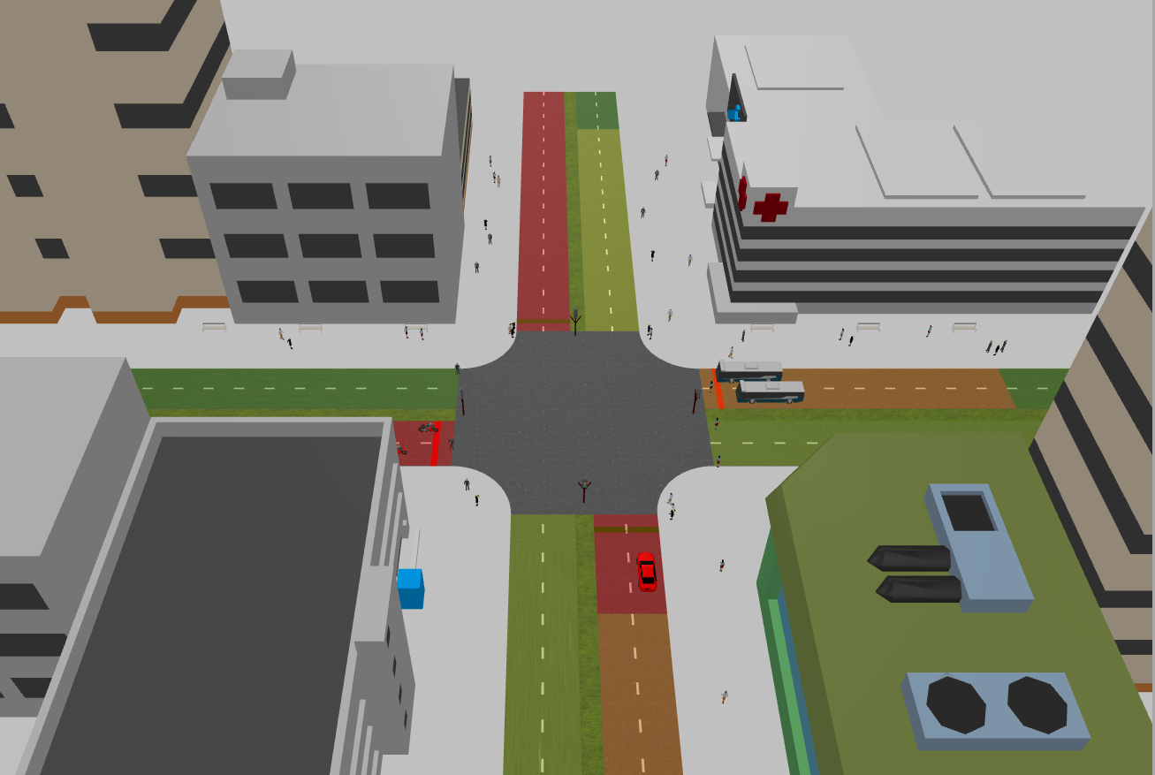
Figure 5. Simulation Model using Anylogic Simulation Software

Simulation is a useful or powerful tool for analyzing complex systems and used in order to study real-life systems which do not currently exist [9]. Good for representing complex systems, the utility of the technology for finding the “answer”. Easy to learn and are applicable to a wide range of problems. Figure 5 shows the actual simulation model created by the researchers using Anylogic Simulation Software.

Simulation Results
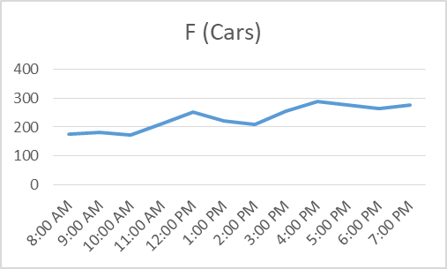

Figure 6. Status plot of number of car and the time in the system

Figure 6 shows that the maximum number of vehicle passed on the intersection road are peaking around 4:00 pm to 5:00 pm and lowest number of customer at 8:00 am to 10:00 am.

Conclusion
- The objective of simulation model is to presents a real
- traffic situation in to dynamic model.
The objective of simulation model is to presents a real traffic situation in to dynamic model that represent the real presentation of the model. Developing a simulation model of Traffic system can be a great tool to accurately recreate the traffic as observed and measured. The application of model to the real traffic can be helpful to avoid the traffic problems occurring on the streets also avoiding incidents and accidents leading towards traffic problem resolution.

Recommendation
The researchers recommend to add more realistic parameters that will be measured to add more data collected and adds more analysis to the traffic simulation of the model. The researcher also suggest to add more models of vehicle and traffic lights model.

References

- J.G. Shanthikumar, R.G. Sargent. A Unifying View Of Hybrid Simulation/Analytic Models And Modeling. Operations research, 31(6), pp.1030-1052 (1983).
- A. D. May, Traffic Flow Fundamentals, Prentice Hall Englewood Cliffs, New Jersey (1990).
- S. Mahajan, A. Umadekar, K.Jethwa. New Concept Of Traffic Rotary Design At Road Intersections. Procedia-Social and Behavioral Sciences, 96, pp.2791-2799 (2013).
- M. Friedrich. Multimodal Transport planning. Stuttgart University, Germany (2015). (Lecture Notes).
- J. Barcello. Fundamentals of Traffic Simulation. International Series in Operations Research and Management Science. Barcelona, Spain, pp. 68-69 (2010).
- Hilt B., Berbineau M., Vinel A., PirovanoA. (2017) "Highway Road Traffic Modeling for ITS Simulation”, Networking Simulation for Intelligent Transportation Systems: High Mobile Wireless Nodes, Wiley. pp 165-184,ISBN 9781848218536.
- A.K. Rathi, Z.A. Nemeth. Freesim: A Microscopic Simulation Model Of Freeway Lane Closures (abridgment), 91, pp. 21-24 (1996)
- B.D. Greenshields, W. Channing, H.A. Miller. A Study Of Traffic Capacity. In Highway research board proceedings. National Research Council (USA), Highway Research Board, 14, pp. 448-477 (1935).
- Dr. Hans Kraml “Simulation Theory versus Theory Theory”, Universit¨at Innsbruck eingereicht bei Herrn Univ Innsbruck, M¨arz 2002.

